EXPERIMENT 1
Nikhil Kadam
D20A - 12
Big Data Analytics for Personalized Content Recommendation and Viewer Engagement in the OTT / Entertainment Industry
Domain: Entertainment & OTT

1. Title of the Case Study
Big Data Analytics for Personalized Content Recommendation and Viewer Engagement in the OTT / Entertainment Industry.

2. Aim
To study the role and application of Big Data in the Entertainment and OTT (Over-The-Top streaming) domain, and to design a case-study roadmap for a personalized content recommendation and viewer engagement analytics system that will be progressively implemented across the Big Data Analytics laboratory experiments (HDFS, MapReduce, Hive, MongoDB, Spark, Streaming, MLlib, Recommendation Systems and Dashboard Development).

3. Introduction to the Domain
The entertainment industry has been transformed by the rise of OTT (Over-The-Top) streaming platforms such as Netflix, Amazon Prime Video, Disney+ Hotstar, and JioCinema. Every play, pause, skip, rating, search and scroll generates data, and the sheer scale of subscribers across geographies means this data grows exponentially every second. Traditional relational systems cannot economically store or process this volume, variety and velocity of data, which is precisely where Big Data technologies become essential.
By leveraging Big Data Analytics, OTT platforms can understand what a viewer likes, when they watch, on what device, and why they abandon a show midway. This enables platforms to move away from generic, one-size-fits-all content catalogues toward hyper-personalized recommendations, targeted content acquisition, and improved subscriber retention. In a traditional recommendation approach, suggestions are often static or based on simple popularity charts. Using Big Data, the platform instead considers each viewer's watch history, genre affinity, ratings, and even sentiment expressed in reviews, generating recommendations that are dynamic and viewer-specific.

4. Problem Statement
OTT platforms generate massive volumes of heterogeneous data -streaming logs, clickstreams, ratings, reviews, subscriber profiles and content metadata -at very high velocity from millions of concurrent viewers. Existing recommendation and analytics pipelines built on traditional databases struggle to scale, and fail to combine structured (subscriber/billing data), semi-structured (clickstream/JSON logs) and unstructured (reviews, social media chatter) data into a single, real-time view of viewer preference. The problem addressed by this case study is: how can Big Data technologies be used to ingest, store, process and analyze large-scale, multi-format OTT viewing data to generate accurate, real-time, personalized content recommendations while also predicting subscriber churn and content demand?

5. Objectives
- To design a scalable Big Data pipeline capable of integrating structured, semi-structured and unstructured entertainment data, along with simulated streaming events.
- To store heterogeneous viewer and content data efficiently using HDFS, HBase and MongoDB.
- To process large-scale viewing logs using MapReduce and Apache Spark for batch and real-time analytics.
- To build a content recommendation engine using collaborative filtering / Spark MLlib based on viewing history and ratings.
- To perform sentiment analysis on viewer reviews and social media mentions to gauge content reception.
- To predict subscriber churn and forecast content demand/trending titles.
- To visualize insights through an interactive analytics dashboard supporting business decisions.

6. Data Sources
- MovieLens 32M dataset (GroupLens Research) – primary dataset containing over 32 million ratings, more than 2 million tags, user IDs, movie IDs and timestamps.
- MovieLens movie metadata – movie titles, genres and other catalogue information associated with the MovieLens dataset.
- TMDB API – used as a secondary source to enrich movie/content information with details such as genres, cast, crew, release information and other content metadata.
- MovieLens tags and other publicly available review/text data – used for analysing viewer preferences and performing optional sentiment analysis.
- Simulated playback/clickstream events – play, pause, seek, skip and viewing-session events generated from timestamped user activity to demonstrate real-time stream processing.
- Derived viewer profiles – customer/viewer preference features created from ratings, tags, viewing history and interaction patterns.
- Trending and demand indicators – calculated from ratings, timestamps, popularity and interaction data rather than assumed to be directly available from the primary dataset.

7. Types of Data
- Structured: User IDs, movie IDs, ratings, timestamps, movie titles and genre information.
- Semi-structured: API responses and content metadata obtained from sources such as TMDB, along with simulated JSON-format playback/clickstream events.
- Unstructured: Movie tags, viewer reviews and other publicly available text such as discussion/forum content used for optional sentiment analysis.
- Streaming: Simulated real-time playback and interaction events generated from historical timestamped activity to demonstrate incremental processing using Spark Streaming.

8. The 5 Vs of Big Data - Justification
Internally Generated & Third-Party Data | Key 'V' Characteristic | Justification
User ratings, tags and historical interactions | Volume | MovieLens 32M contains more than 32 million ratings and over 2 million tags, providing a sufficiently large dataset for distributed storage and processing.
Timestamped ratings and simulated playback events | Velocity | Timestamped interactions allow the system to study changing viewer activity, while simulated playback events demonstrate how continuously arriving data can be processed.
Ratings, tags, movie metadata, API data and review text | Variety | The case study combines structured records, semi-structured API/JSON data and unstructured text, requiring different storage and processing approaches.
Viewer reviews, tags and social/discussion text | Veracity | Text-based data may contain noise, bias, spam or sarcasm, so cleaning and validation are important before sentiment or preference analysis.
Personalized recommendations, engagement analysis, churn prediction and demand forecasting | Value | Converting viewer interactions into recommendations and actionable insights can improve content discovery, viewer engagement and content-related decisions.

9. Analysis -How Big Data Benefits the OTT/Entertainment Industry
- Personalized content recommendations: Each viewer has distinct genre, language and mood-based preferences. Using Big Data, the platform analyses past watch history and similar-viewer behaviour to recommend titles that keep the subscriber engaged.
- Reducing subscriber churn: By mining engagement patterns (drop-off points, binge behaviour, inactivity), the platform can identify subscribers at risk of cancelling and proactively re-engage them with targeted content or offers.
- Content demand forecasting: Analysis of trending searches, regional viewership and social buzz helps content teams decide what new titles or seasons to commission or license next.
- Sentiment analysis on reviews: Mining reviews, ratings and social media chatter reveals genuine audience reception of a show, beyond just star ratings, helping marketing and content teams respond quickly.
- Optimized content delivery: Analysing regional and time-of-day viewing spikes allows the platform to optimize CDN caching and streaming quality (adaptive bitrate) for a smoother viewing experience.
- Improved content acquisition & rating: Aggregated ratings, reviews and viewership data help the platform benchmark titles against each other and negotiate smarter licensing/production decisions.

10. Proposed Big Data Workflow
The overall data flow for this case study follows the standard Big Data pipeline suggested for the course, adapted to the OTT/entertainment context: raw data from multiple sources is ingested, stored in a distributed file system, organized for query using Hive/MongoDB, processed at scale with MapReduce/Spark, analyzed, and finally surfaced to business stakeholders through a dashboard.

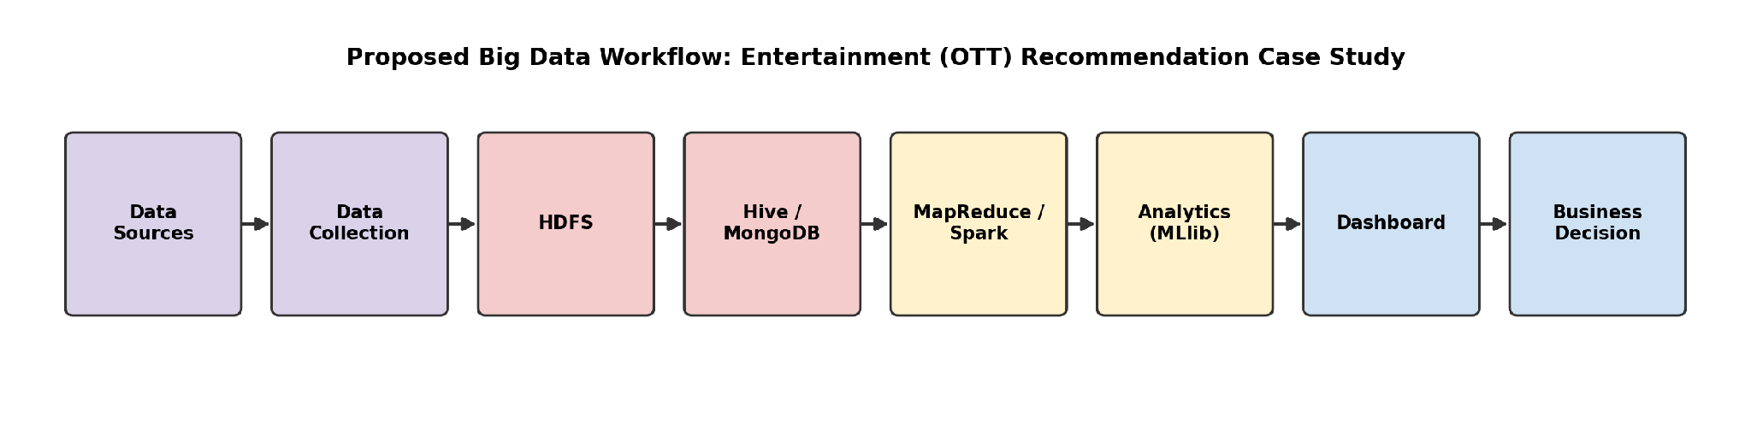
Fig. 1 -Proposed Big Data Workflow for the OTT Recommendation Case Study

11. Methodology for the Roadmap
The recommendation methodology captures the content catalogue and each viewer's watch history, ratings and reviews, derives viewing preferences, computes similarity between viewers/content and performs sentiment analysis, and finally generates personalized recommendations and a 'Watch Next' ranking that is served back to the viewer -whose subsequent interactions feed back into the system, continuously refining future recommendations.
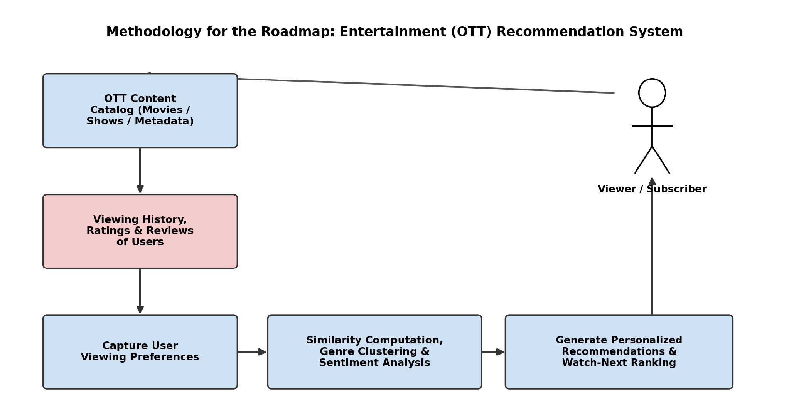
Fig. 2 -Methodology for the Roadmap

12. Big Data Ecosystem Design / Architecture
The architecture is organized in five layers, from raw data sources at the bottom to viewer-facing applications at the top, mirroring the Hadoop ecosystem components used at each stage.
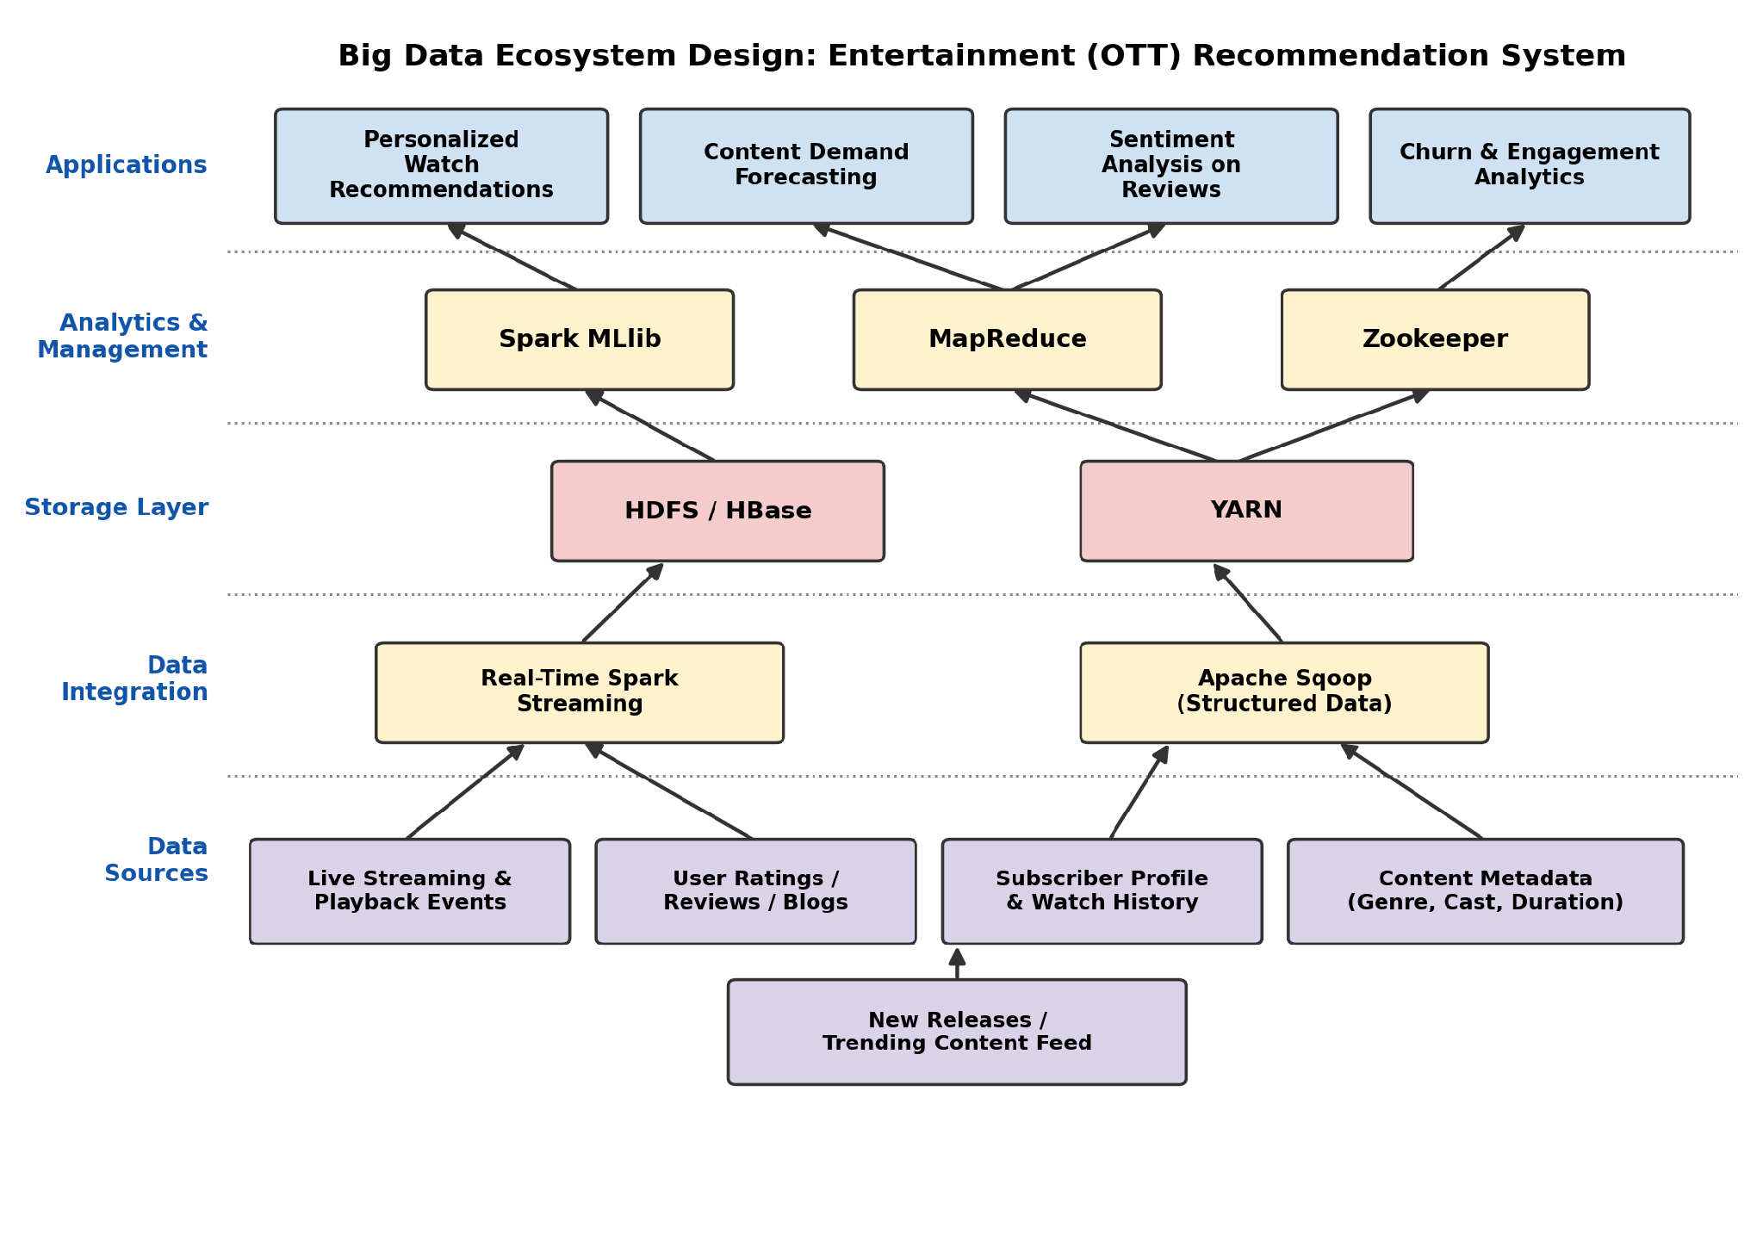
Fig. 3 -Big Data Ecosystem Design (Layered Architecture)

13. Hadoop Ecosystem Components to be Used
- HDFS (Hadoop Distributed File System): Provides fault-tolerant, distributed storage for the massive volume of raw playback logs, content metadata and review text collected from all sources.
- Apache HBase: A distributed, column-oriented NoSQL database built on HDFS that can be used for fast random read/write access to frequently accessed viewer profiles, interaction summaries and recommendation-related data.
- Apache Hive / MongoDB: Hive provides a SQL-like interface over structured data in HDFS for ad-hoc querying, while MongoDB stores semi-structured clickstream/JSON event data and content metadata flexibly.
- MapReduce: A distributed batch-processing model used to compute aggregate statistics such as rating counts by genre, most-rated titles, user activity summaries and per-title rating distributions
- Apache Spark (incl. MLlib & Structured Streaming): Used for fast in-memory processing: Spark Structured Streaming ingests real-time playback events, while Spark MLlib powers the collaborative-filtering recommendation engine and churn-prediction models.
- Apache Sqoop: Transfers bulk data between Hadoop and relational databases. It can be considered as an optional component if relational viewer or business data is introduced later; it is not required for the core MovieLens/TMDB data pipeline.
- YARN: Manages and allocates cluster resources across the various batch (MapReduce) and in-memory (Spark) processing jobs running concurrently on the cluster.
- Zookeeper: Coordinates configuration management and distributed synchronization across the Hadoop cluster nodes, ensuring reliable operation of HBase and Spark Streaming jobs.

14. Expected Outcomes
- A working, scalable pipeline that ingests and stores multi-format OTT viewing data (structured, semi-structured, unstructured, streaming).
- A personalized recommendation engine that improves recommendation relevance over simple popularity-based ranking.
- A churn-prediction model that flags at-risk subscribers ahead of cancellation.
- Sentiment scores for titles derived from viewer reviews and social media, aiding content and marketing decisions.
- An interactive dashboard presenting viewership trends, top genres, churn risk and content demand forecasts to business stakeholders.

15. Conclusion
This case study demonstrates that Big Data Analytics, applied to the Entertainment and OTT domain, can transform a traditionally static content-delivery model into a dynamic, viewer-centric ecosystem. By leveraging the Hadoop ecosystem -HDFS, HBase, Hive/MongoDB, MapReduce, Spark, Sqoop, YARN and Zookeeper -a platform can process the huge Volume, Velocity and Variety of viewing data, while addressing Veracity concerns in review data, to unlock significant business Value through personalized recommendations, churn reduction and smarter content decisions. This roadmap will be extended in subsequent experiments to implement each stage of the pipeline in practice.

16. References
- MovieLens Dataset, GroupLens Research -https://grouplens.org/datasets/movielens/
- Netflix Prize Dataset -https://www.kaggle.com/datasets/netflix-inc/netflix-prize-data
- TMDB (The Movie Database) API -https://www.themoviedb.org/documentation/api
- Apache Hadoop Documentation -https://hadoop.apache.org/docs/
- Apache Spark Documentation -https://spark.apache.org/docs/latest/
- Apache Hive Documentation -https://hive.apache.org/
- MongoDB Documentation -https://www.mongodb.com/docs/
- TMDB API Documentation. https://developer.themoviedb.org/docs/getting-started

